XVRView
Mobile client
User manual

V1.2.3

table of Contents
table of Contents Error: Reference source not found
1. Product introduction 2
1.1product description 2
1.2Product main function 2
2. Software Installation 4
2.1Operating environment requirements 4
2.2 Get software 3
3. Software operation instructions 4
3.1Introduction to the login interface 4
3.2 Live preview 7
3.3 Playback 9
3.4 Device manager 10
3.5 Alarm manager 15
3.6 Files 16
3.7 Alarm notification 17
3.8 Find super password 15
3.9 About help 16
3.10 logout 17
3.11 Account management 20
3.12 Language switching 20

1.Product introduction

1.1 product description
XVRView Is a professional mobile video monitoring software, with the specified DVR, network camera use.

1.2 Product main function
The main function：
- Local login、register log in、change Password、forget password
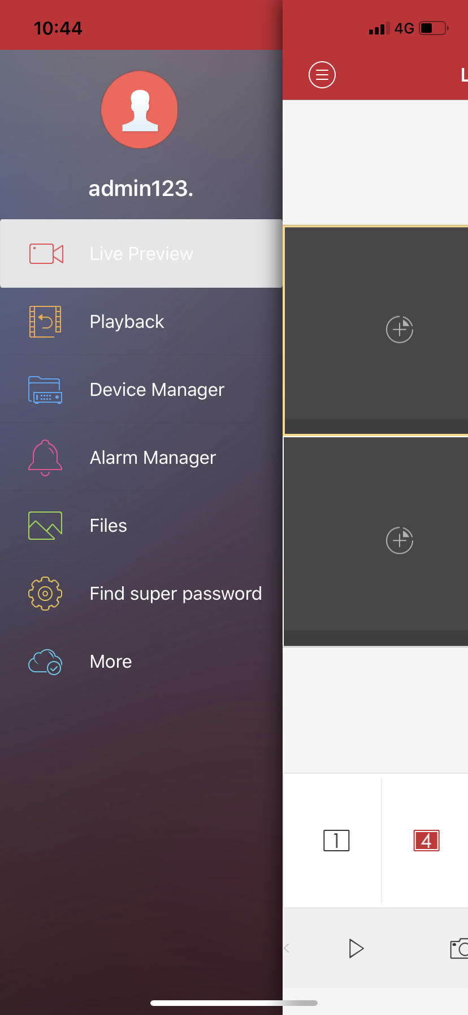
- Live preview（Intercom、monitor、PTZ control）
- Device manager (add, delete, modify, set)
- Playback
- Alarm manager
- Files
- Find super password
- System configuration
- About help
- User Management
- Logout

2.Software installation

2.1 Operating environment requirements
Apple mobile client requires iOS6.0 or above system; Android mobile client requires android 2.2 and above system.

2.2 Get software
Apple mobile phone user：Search for XVRView installations on the Apple App Marketplace.
Android phone users：Search for XVRView installations in major application markets such as Google Play, App Store, and Android Market.

3. Software operation instructions

3.1 Introduction to the login interface
After the installation is successful, click 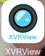 the software icon on the phone and the software will run. Start the program to enter the login interface, as shown below:
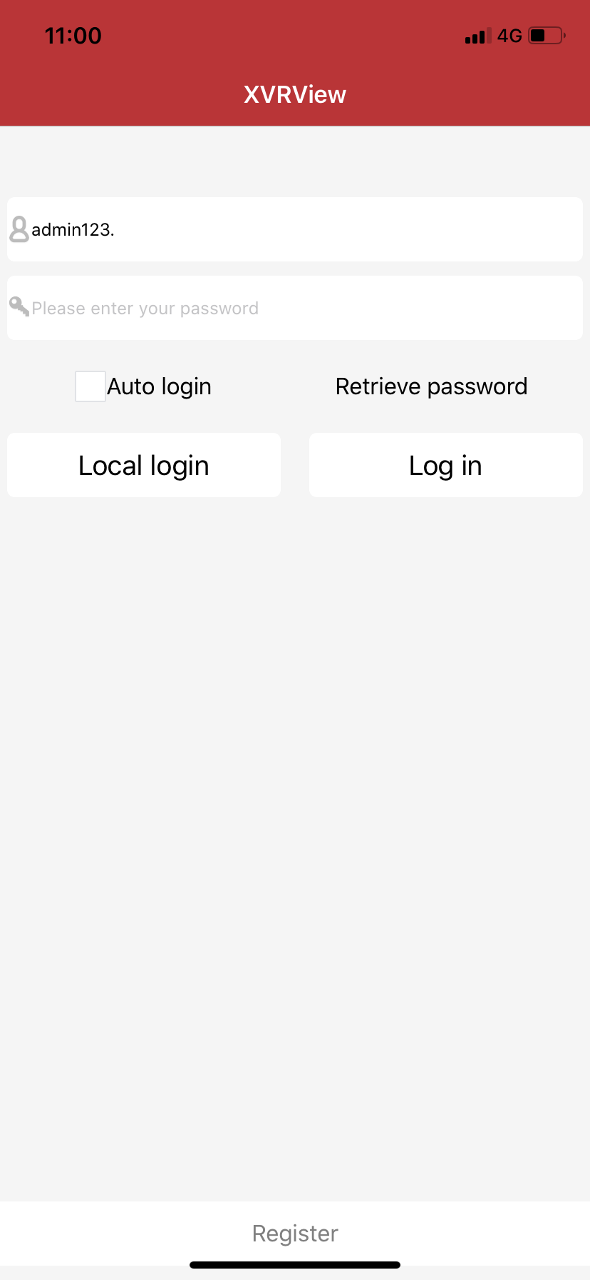
Features | Description
log in | Account login, device information cloud storage
automatic log-in | Check the box to automatically log in when you start the software.
forget password | After selecting, retrieve the account password according to the operation steps.
Local login | No need to enter the account directly, the device is saved on the phone
registered | Register a new account

Figure3.1a

- User registration
Register an account for cloud storage of our user information and related device list. In the login menu, click the “User Registration” button to jump to the registration interface：
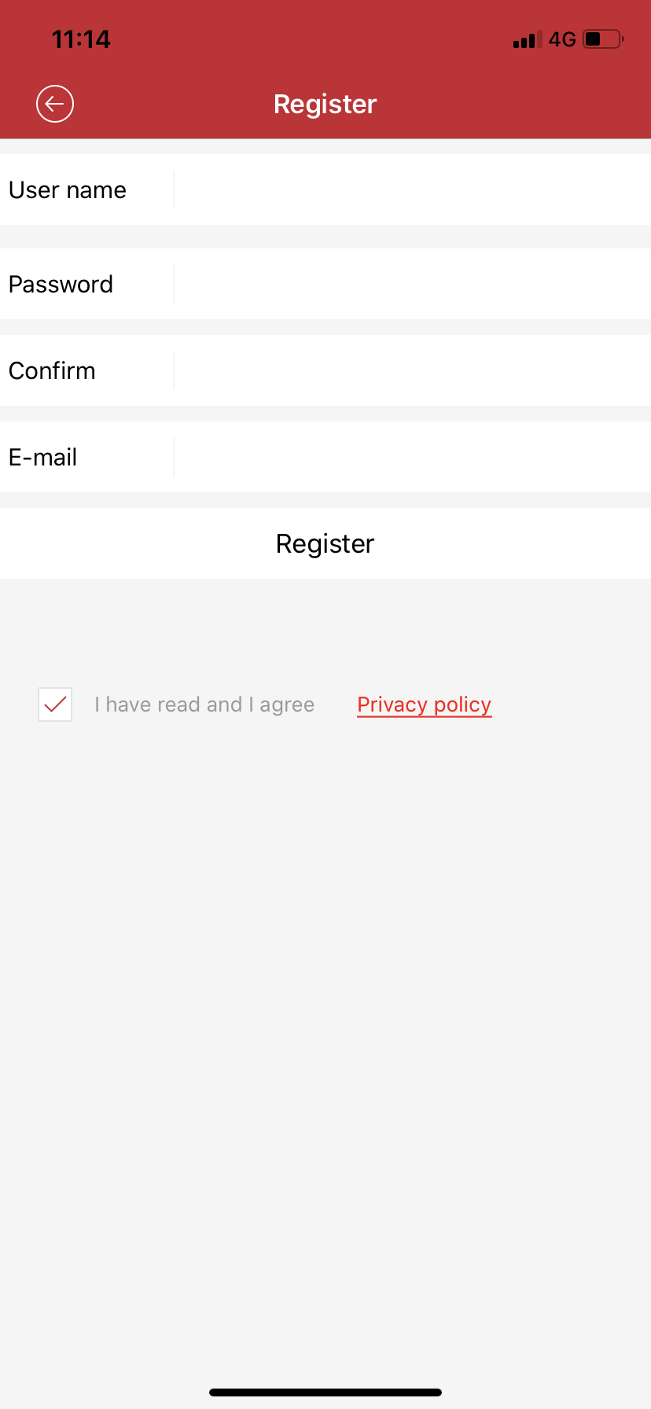
Username: User at login (only letters and numbers are allowed and "-", "_", "@" characters)
Password: login password (6 digits or more)
Confirm password: Enter the password again
E-mail: confidential security mailbox, please fill in correctly, you can reset the password when you forget your password.
Phone: used to write the corresponding mobile number
Figure 3.1 b
- Retrieve password
In the login interface, click the "Retrieve Password" button to jump to the "Retrieve Password" interface：
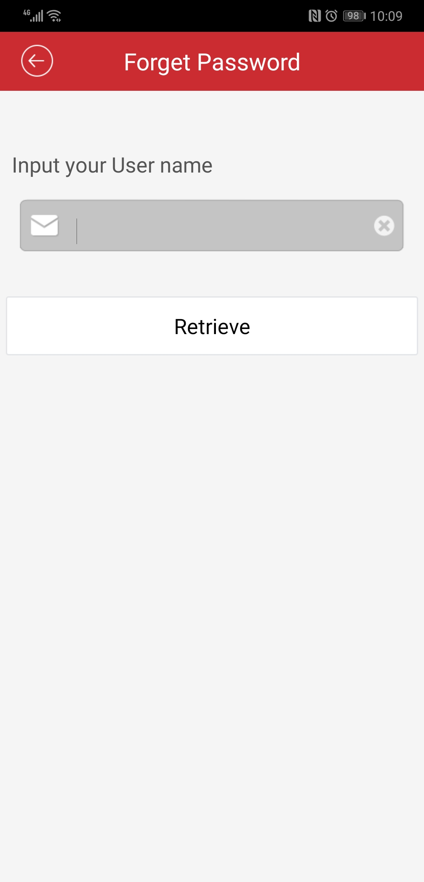
- Enter the username to retrieve the password
- Click “Retrieve Password”, the system will send a link to reset the password to the mailbox set when we registered, enter the mailbox and set the password according to the prompt.
Figure3.1 c

3.2 Live preview
Click the device icon in the device list to enter the playback interface, as shown below：
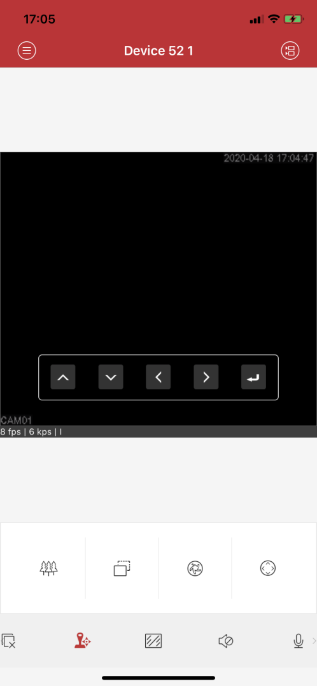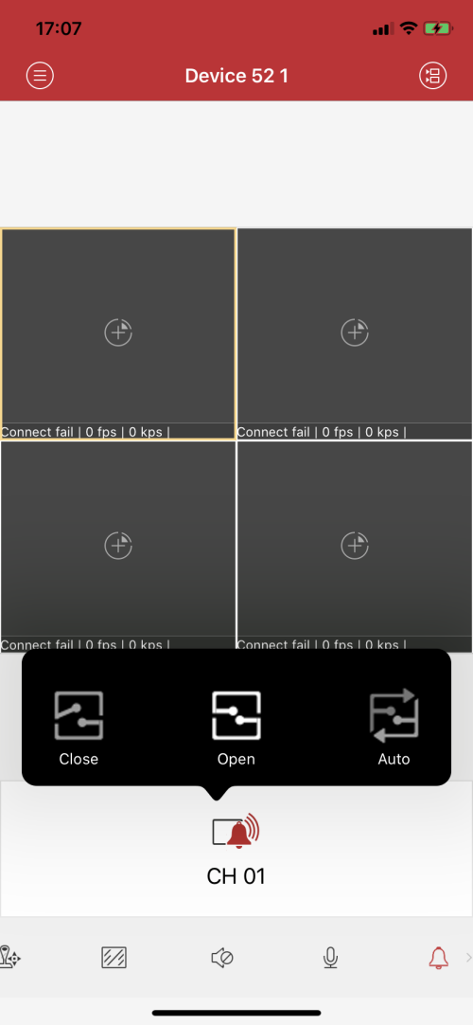
Figure3.2 a Figure3.2 b

Double-click the window during playback to enlarge the screen, and the horizontal screen can be played in full screen.

Video monitoring interface button function introduction, as shown in the following table：
Button icon | Features
 | View main menu
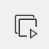/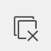 | Play/stop
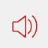/ | Turn on/off monitoring
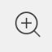 | Play channel zoom
 | Capture
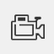 | Local video
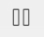/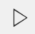 | Pause/play the selected channel

Button icon | Features
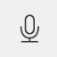 | Start the intercom
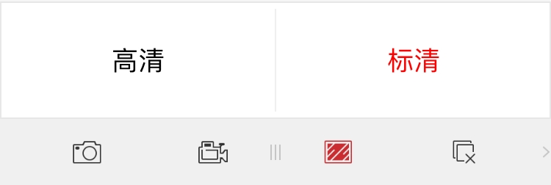 | Code stream switching
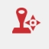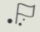  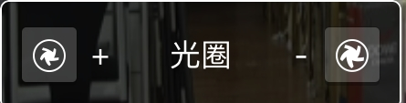  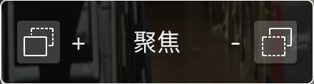  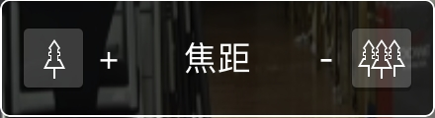 | PTZ lens control
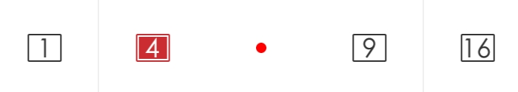 | Multi-screen switching
icon | Features
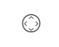 | Start coaxial control
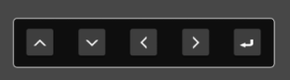 | Coaxial control operation menu (up, down, left, right, OK)
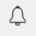 | Alarm output settings

icon | Features
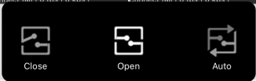 | Alarm output is on
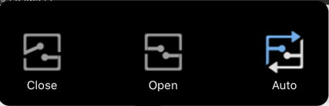 | Alarm output adaptive
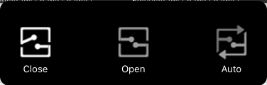 | Alarm output off

3.3 Playback

The mobile client can access the remote device and retrieve the video data stored on the hardware. The device needs to have storage to enable remote playback.
In the real-time preview interface, select the playback window to be played back, click the remote playback menu to enter the playback interface, and play the video on the same day by default.
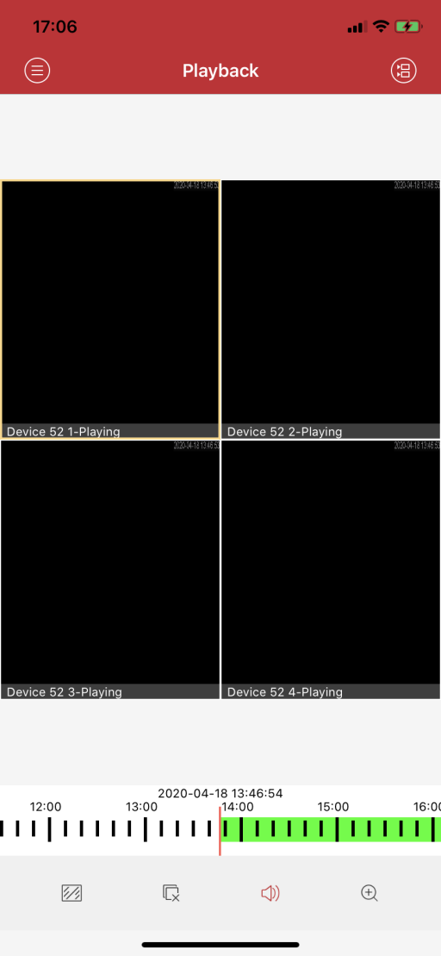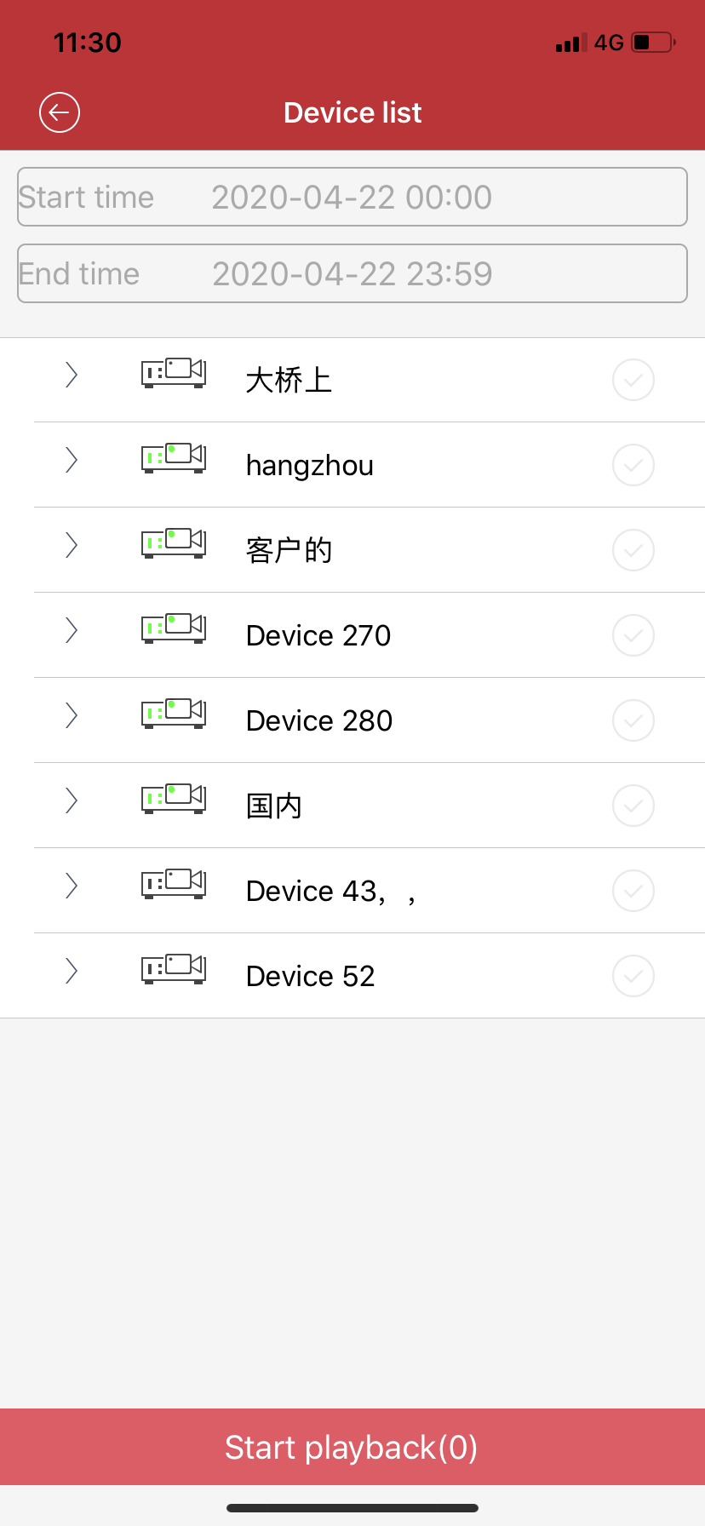
1、Click on the channel to select another date and select the date to play.
2、The green area below is the recording time period, and the progress bar can be dragged to locate the time to be played.
3、The playback function can also choose whether to play the main stream or the sub-stream to play the video file.(PS: The device must support the primary substream recording function.)
Figure3.3a Figure3.3b

3.4 Device manager
Go to the main menu interface and select “Device Management” to enter the management interface.
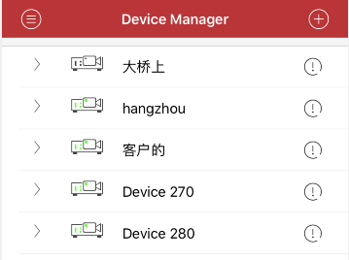
icon | Function Description
 | Return to main menu list
 | Add device
 | Click to modify the connection parameters

Figure3.4a

- Add device
Click the Add button in the upper right  corner to enter the device add interface. After entering, you can manually add the connection parameters of the device. You can also click the search button to search for devices in the LAN.
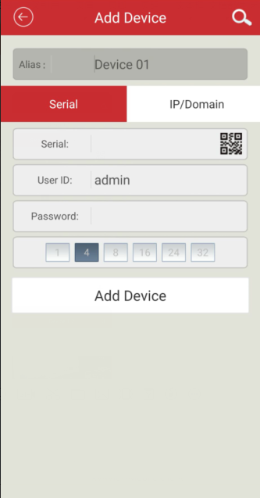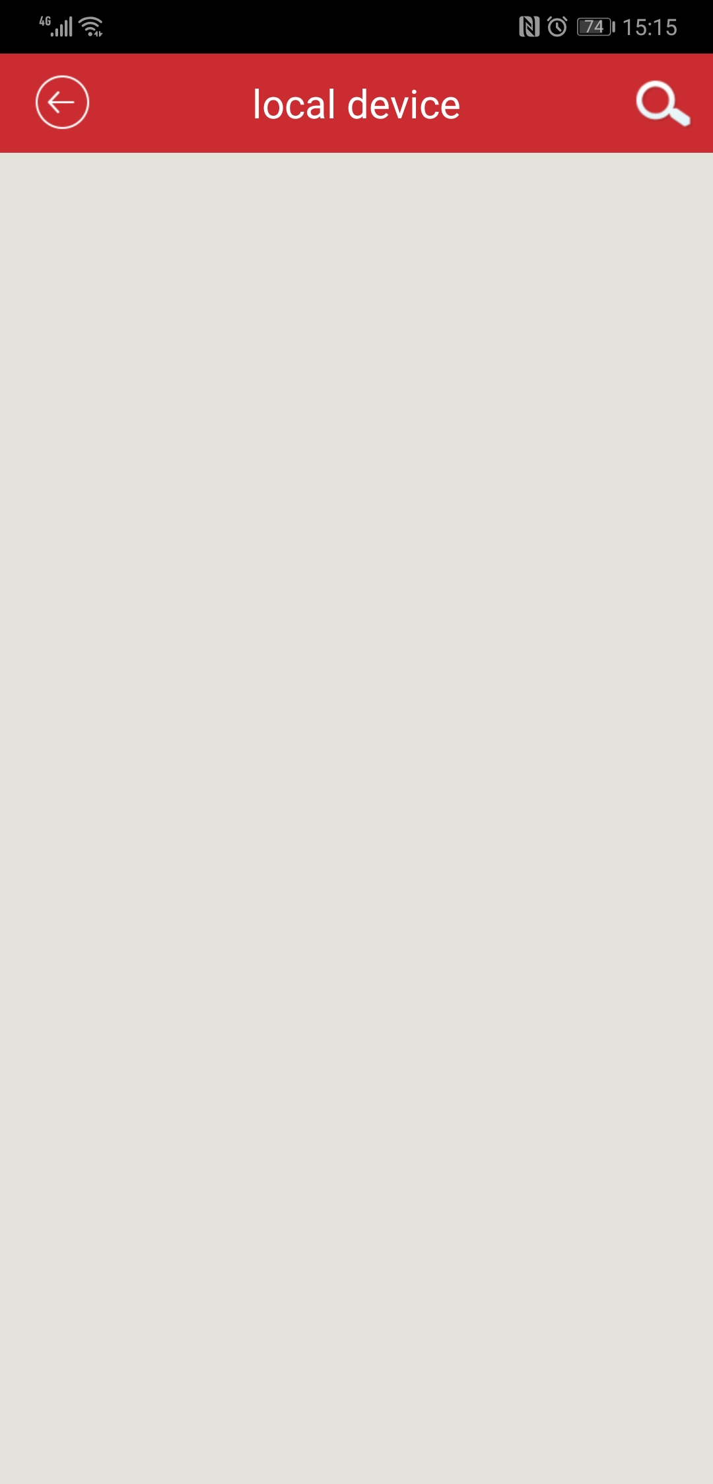
Figure3.4b Figure3.4c

- Connection mode：Serial number and IP/domain name are directly connected in two ways.。Cloud mode is connected using device serial number；The ip mode uses traditional ip addresses or dynamic domain names and ports to connect devices. By default, the serial number is added. Click the IP/domain name above to switch to the ip mode.
- name：It is the name of the monitoring device, which can help you identify the location of the device, so it is recommended that you name it according to the location where the device is located. The name will be displayed under the device icon and will be displayed on the title during playback.
- serial number：The unique serial number of the device cloud connection can be obtained by searching for the label or LAN of the device. When inputting, you can also click the QR code button on the right side of the input box to scan the QR code.
- username：User name of the front-end device, the default is admin；
- PassWord：The password of the front-end device matches the username of the front-end device. The default is blank.

After filling in the settings, click OK. After the point is finished, it will automatically pre-connect and check whether the device information is filled in properly. If it is correct, it will automatically return to the “Device List” interface. Click the device to view the video. If it is incorrect, click the device, prompt: device.

- Modify or delete devices
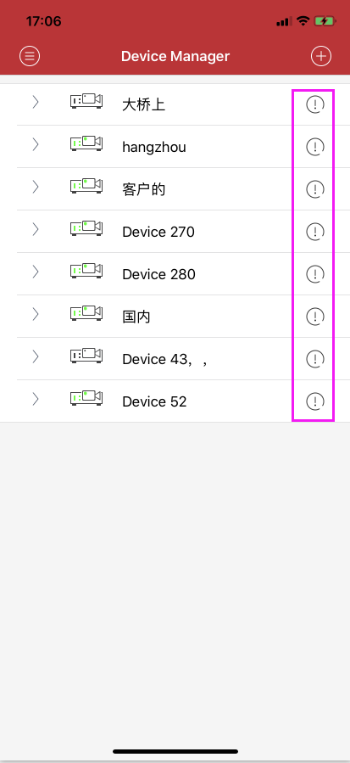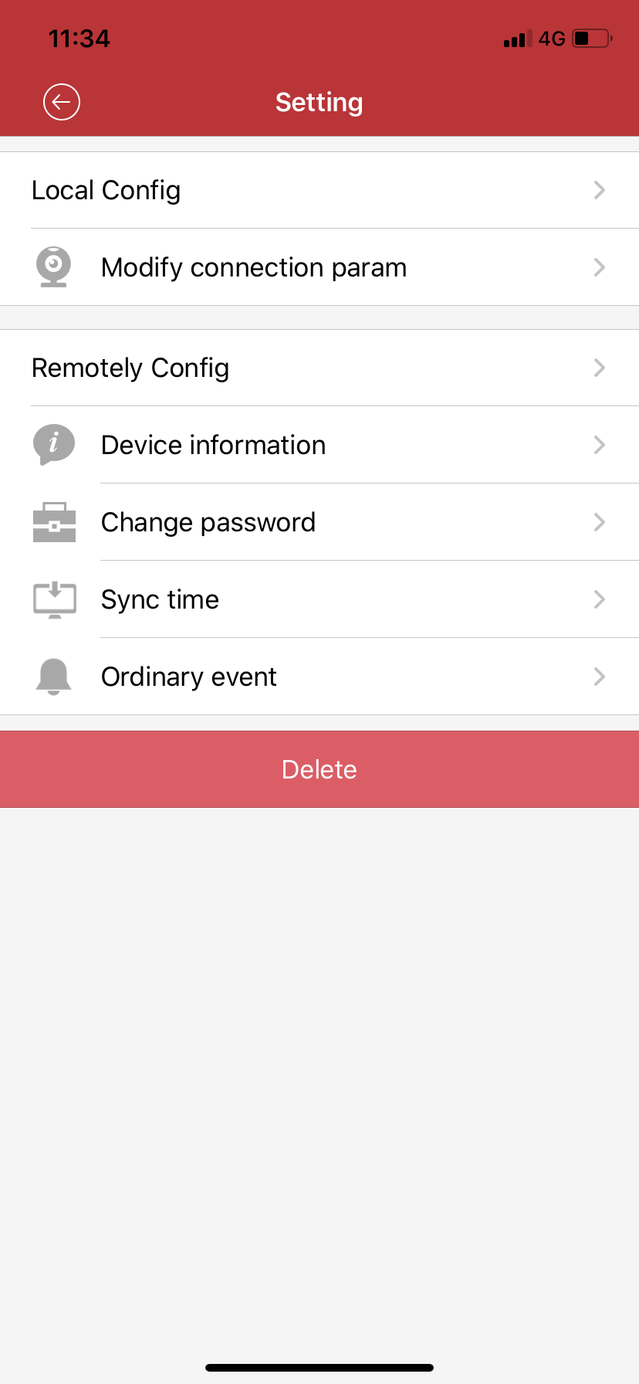
Figure3.4d Figure 3.4e

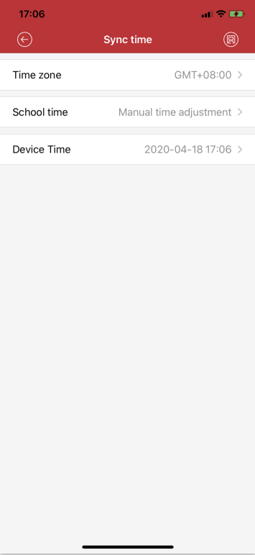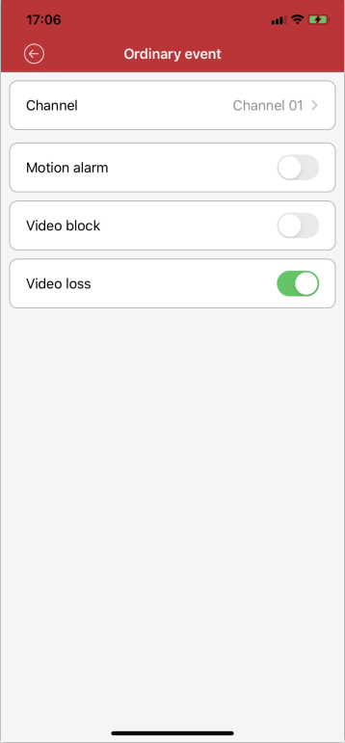
Figure3.4f Figure3.4g

- Connection parameter：The name can be modified, the serial number to be connected, the username, password, and connection parameters.
- Remote configuration：Change device password, set camera time, and view device information.
- Delete device：Click the "Delete" button and click "OK" to delete.
- Time zone: Set the corresponding time zone according to different regions (Figure3.4f )
- Time adjustment mode: NTP time adjustment and manual time adjustment can be set (Figure3.4f )
- Motion detection: After opening, you can receive motion detection alarm through APP(Figure3.4g )
- Video occlusion: After opening, you can receive video occlusion alarm through APP(Figure3.4g )
- Video loss: After opening, you can receive video loss alarm through APP(Figure3.4g )

3.5 Alarm manager
For the lens that successfully defends and turns on the notification, when the device generates an alarm, the device sends an alarm message to the server, and the message is sent to the mobile phone client through the server, and the mobile phone prompts in the notification manner and displays it in the message center.
Click on the delete button in the upper right corner to delete all alarm records.

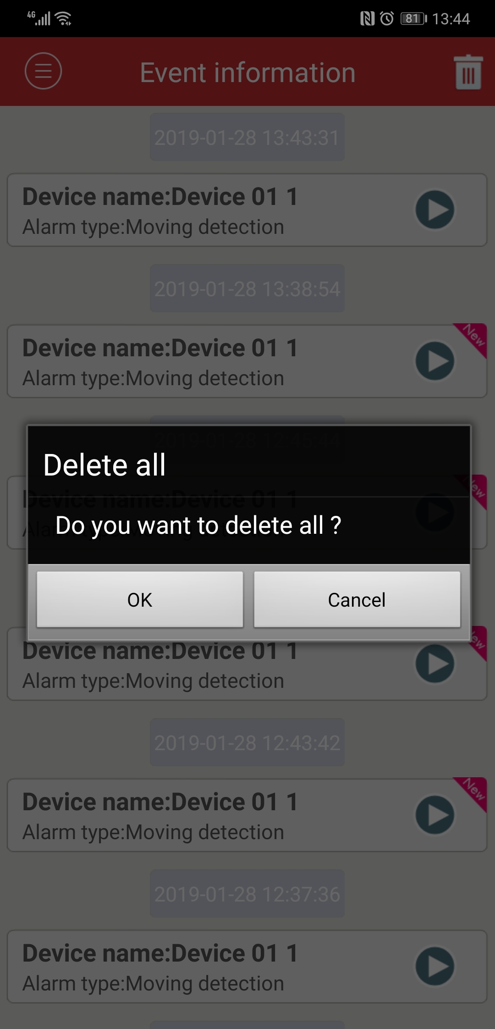
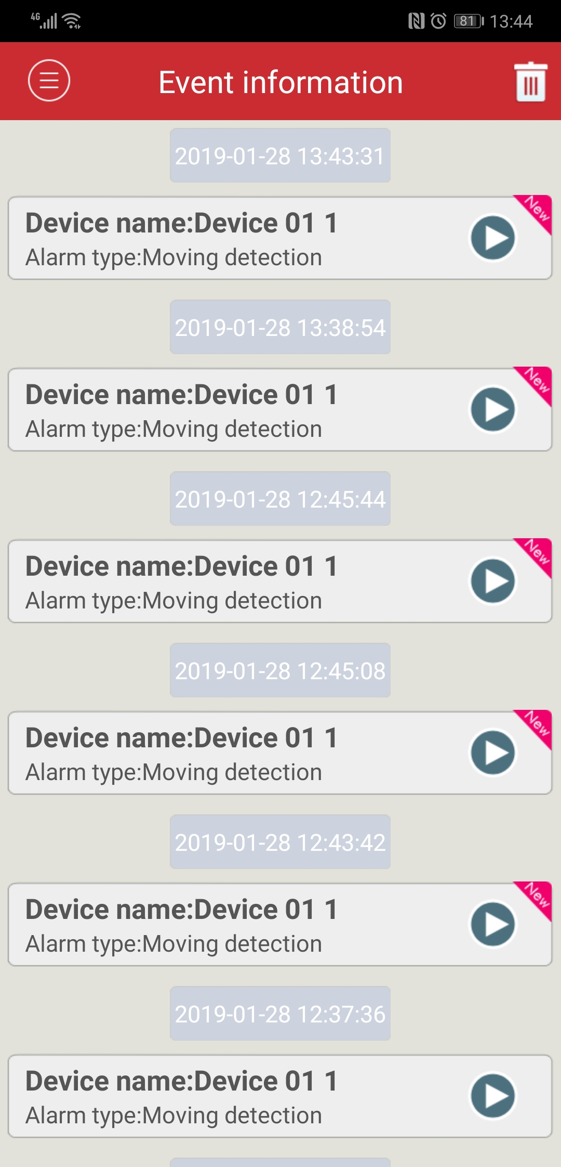
Figure3.5a Figure3.5b
3.6 Files

Click or after the live preview, the generated image is stored directly in the phone, from the menu to the local video or local album to view
- Play image：
- Click on the video thumbnail and select the player to play.
- Click on the captured image to open the view.
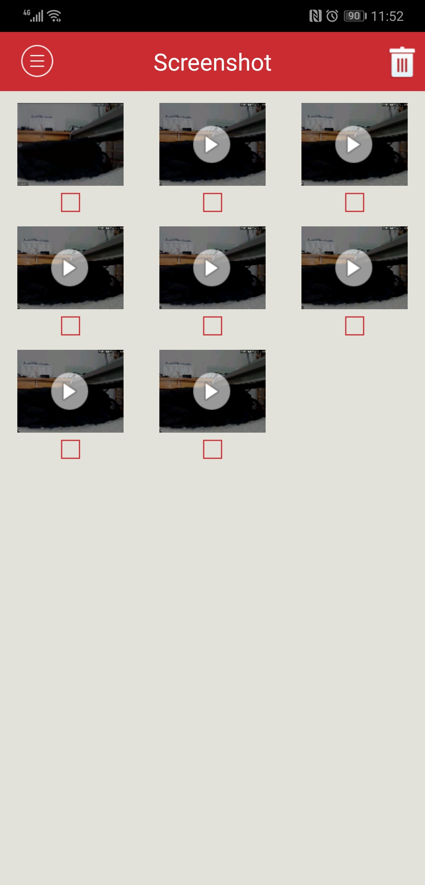
Figure3.6a
- Edit delete：
- Click the “Select” button in the upper right corner, the list will change to the edit selection state, select the file to be deleted and click the button in the upper right corner.
Figure3.6b

3.7 Alarm notification
- Turn on the alarm:The device management interface selects the channel point modification that needs to be alarmed. Enter the setting interface, confirm the channel name of the alarm to be turned on in the alarm arming, open the alarm notification and arming switch, click save, and the prompt is successful.
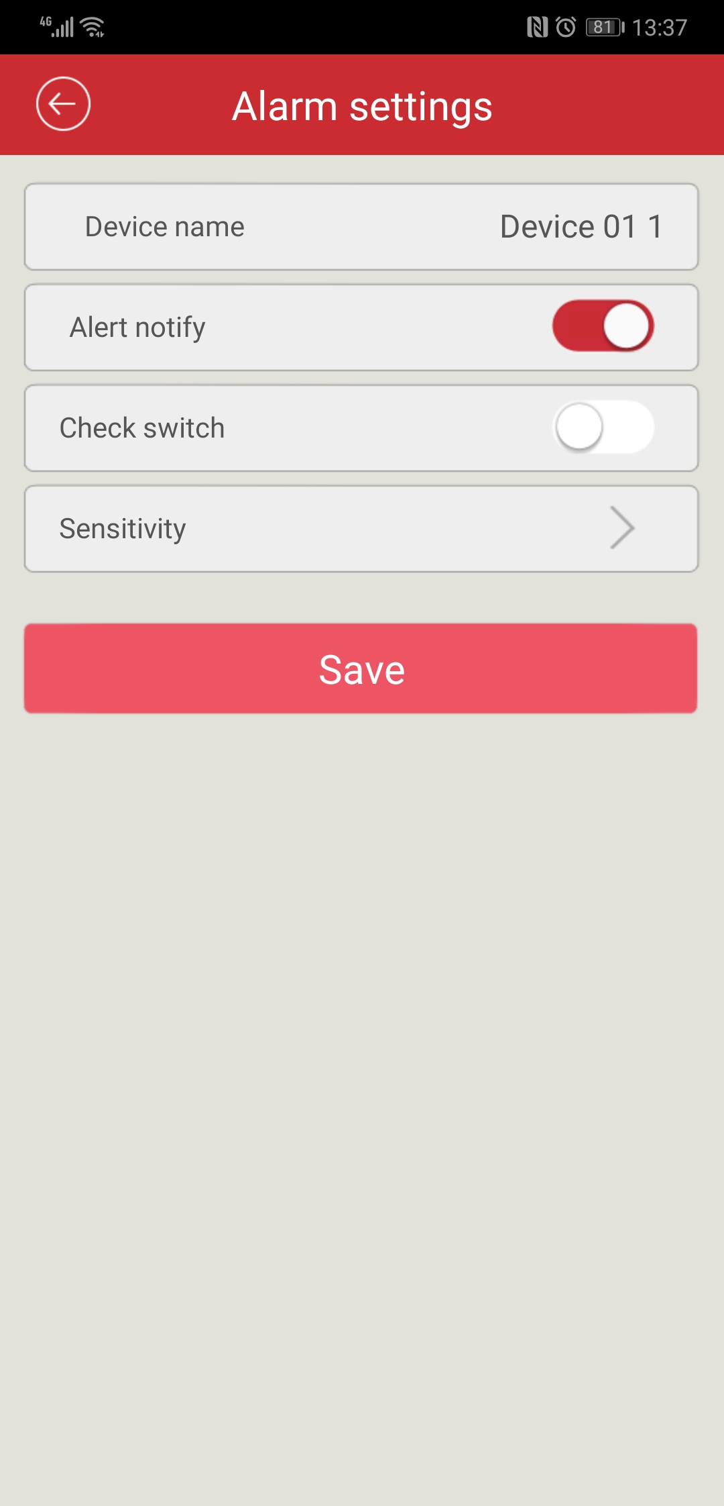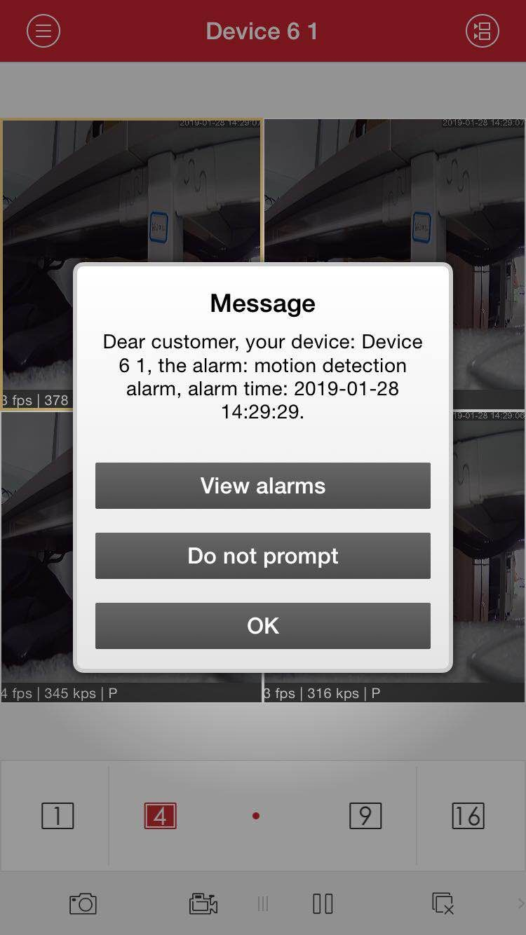
Figure 3.7a Figure3.7b

- Push notification:For the lens that successfully armed and turns on the notification, when the device generates an alarm, the device sends an alarm message to the server, and the message is sent to the mobile client through the server, and the mobile phone prompts by notification. As shown 3.8b

3.8 Find Super password
Super password recovery function: When the user forgets the device password, scan the QR code in the device's password forget function through the APP. The super password can be obtained from the APP to reset the password of the device.
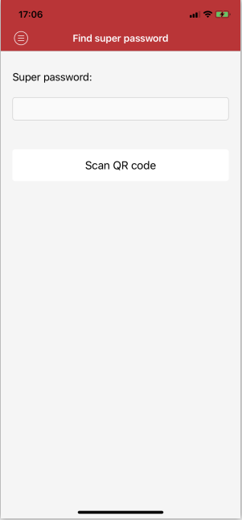

3.9 About help
Can query software version information

3.10 logout
Click "Logout" to log out of the current account login and return to the login interface.

3.11 Account management
Click on the user avatar, you can choose to automatically log in, modify the password function.

3.12 Language switching
When the phone operating system changes language, the language of the software will change. For example, if the mobile operating system language is changed to English, then the language of the mobile phone software will be replaced with English.

